Documentation for Solidworks to Mujoco:

1. Exporting from Solidworks using SW2URDF:
   1. Step 1: Download SW2URDF extension
      1. Repo: <https://github.com/ros/solidworks_urdf_exporter/releases>
   2. Step 2: Assigning frames to your robot
      1. [(170) Frame Assignment For Robotic Manipulators - Direct Kinematics I - YouTube](https://www.youtube.com/watch?v=fNIyNF87q9I&t=244s)
      2. ^ this video should give you a good idea of what assigning frames is and how to know where to place your frames.
      3. Use the Reference geometry 🡪 Coordinate system tool in Solidworks.
         1. A useful tip: Point your coordinate systems toward each other if possible – this will make it easier to code in mujoco later.
   3. Step 3: Using the extension
      1. Follow this video tutorial: <https://www.youtube.com/watch?v=ge3P307TgJI>
      2. Now you should have a folder with the URDF of your robot.
2. Accessing the URDF and converting the URDF to Mujoco:
   * 1. Ref: <https://mujoco.readthedocs.io/en/latest/modeling.html#curdf>
   1. Step 1: Checking if your URDF generated correctly:
      1. Add the mujoco extension after robot name like so:

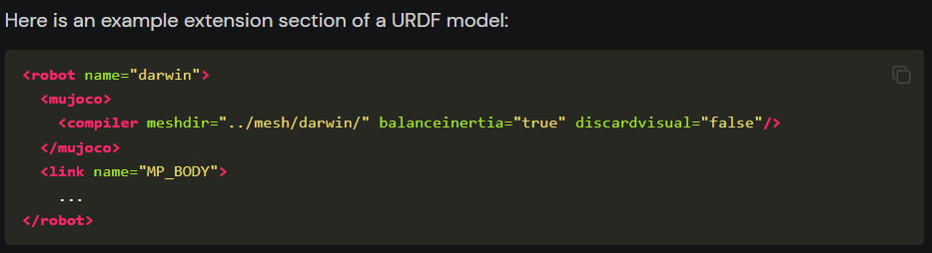

* 1. Step 2: Check collision
     1. After you add the extension, you should be able to drag and drop the file into mujoco and 2 things can happen:
        1. Everything runs < less interesting
        2. Everything runs itself apart < more interesting
           1. If this was the case, you could be running into a collision issue.
           2. You can confirm this by tapping F to toggle the forces vectors and H to toggle the convex hull

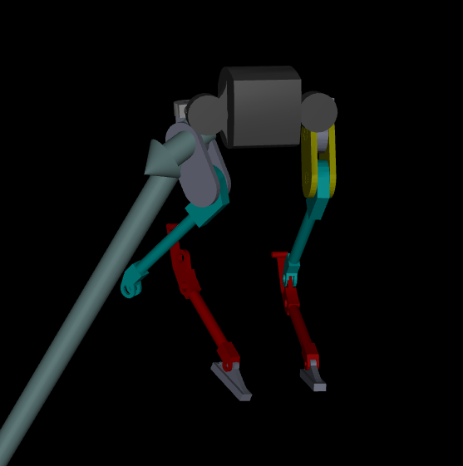

So, you can see there is a huge force coming off the body

* + - * 1. You can fix this collision issue by going into your URDF and change the collision STL file for a simpler geometry.
    1. If there are internal collision even though nothing seems off
       1. Convex hull collision – in the URDF, replace the collision mesh with something else.
  1. Be careful about:
     1. File directory – make sure they are correct; if things doesn’t load, check first